Contents
Analysis 2
The problem identification background 2
Objectives 2
Research 2
Interviews/ surveys 2
Technical Skills 2
Research Table 3
Storyboard 4
Prototype 4
Justification of chosen solution (linked to research) 4
Data modelling 4
Design 5
Design introduction 5

Analysis

The problem identification background
After deciding to make a dungeon crawler game I looked at popular games e.g. The binding of Isaac, Cave blazers and Welcome to the Gungeon. After looking at these games and what people think of them, I had a list of fundamental aspects of dungeon crawler games that I aimed to implement into my game. For the game, the end user would be other people that play these kinds of games.

Objectives
- The databased will only hold 15 scores at a given time but only show 10 on the scoreboard.
- The game should be intuitive and easy to grasp.
- Enemies, items and to a certain extent; the map should be randomly generated ever time the code is run.
- The character should have ranged and melee attacks.
- The character should have animations for almost everything they do to help with emersion.
- Create a boss room that contains a powerful enemy to end the game.
- Have a wide range of sound effects.
- Have an Arcade style leader board in the game.
- Have a main menu that would start and game and not just throw the player in.
- Animate enemy movements.

Research

Interviews/ surveys
When interviewing a pupil in year 13 I told them the current objectives and they had a few suggestions, such as an Inventory that can hold items that appear in rooms and then be used when ever the player wants to. Another suggestion is a start menu that

Technical Skills
A big part of all games is the physics engine that primary deals with collisions as they are a fundamental part of any game. When I first tried to make a collision detector, I started with a coordinate system that fell short but this lead me to find the intercests method which is exactly what I need and I plan to use to use it in the main code to detect when two images are overlapping.
While researching characters for the game I decided on an 8-bit Link from the legend of Zelda game, I chose link because his sprite sheet (an image that contains the character in all positions) is easy to get images from and then animate them. For the player to appear animated I will set different images to the player node when necessary.
It wouldn’t be a game without enemies for the hero to defeat. To do this I found a sprite sheet of all the 8-bit enemies used in the original Zelda game and I plan to implement them and have the hero defeat 6-7 enemies and then defeat a boss to complete the game.

Research Table
Research Type | Date | Description | Main comments gathered.
Collision detector | August, 2019 | Research into how to detect when images are overlapping. | Found the .intercests method.
Changing the players image. | August, 2019 | Changed the players variable type from a node to an Imageview. | ImageViews allow .setImage(PATH) which is how I will change the image attached to the hero.
Character Sprite sheet | August, 2019 | Using a sprite sheet of Link, I resized all the necessary images to 150, 162 pixels. | 17+ images of link that can be used to animate the player.
Animating character | August, 2019 | Using timelines and key getters. I can change the players image when needed. | Using the pictures, I can animate the player to walk, run and attack.
Dynamic arrays. | August, 2019 | Learn to use and implement dynamic arrays that utilise classes. | I can now effectively add enemies and items to the game.
Survey with end user | September, 2019 | End user provided useful and constructive feedback. | Added to objectives:  Inventory, items and a boss room
Translating objects | September,2019 | Understood how the TranslateTransistion method works. | Using this I can move have the enemies and other objects can move and follow the player.
Sound effects | September, 2019 | Using the book javafx for dummies I found the MediaPlayer method. | I can now add sound effects and music to the game.
Score saving to a database. | September, 2019 | Using the sql courses on w3schools I created a database and then a table that saves a name and score | When the game has been beaten the player can save their name and score to a database and scoreboard.
Survey with end user | September, 2019 | Showed them the current model | Added to objectives: Main menu that starts the game and Animating enemy movement.

Storyboard

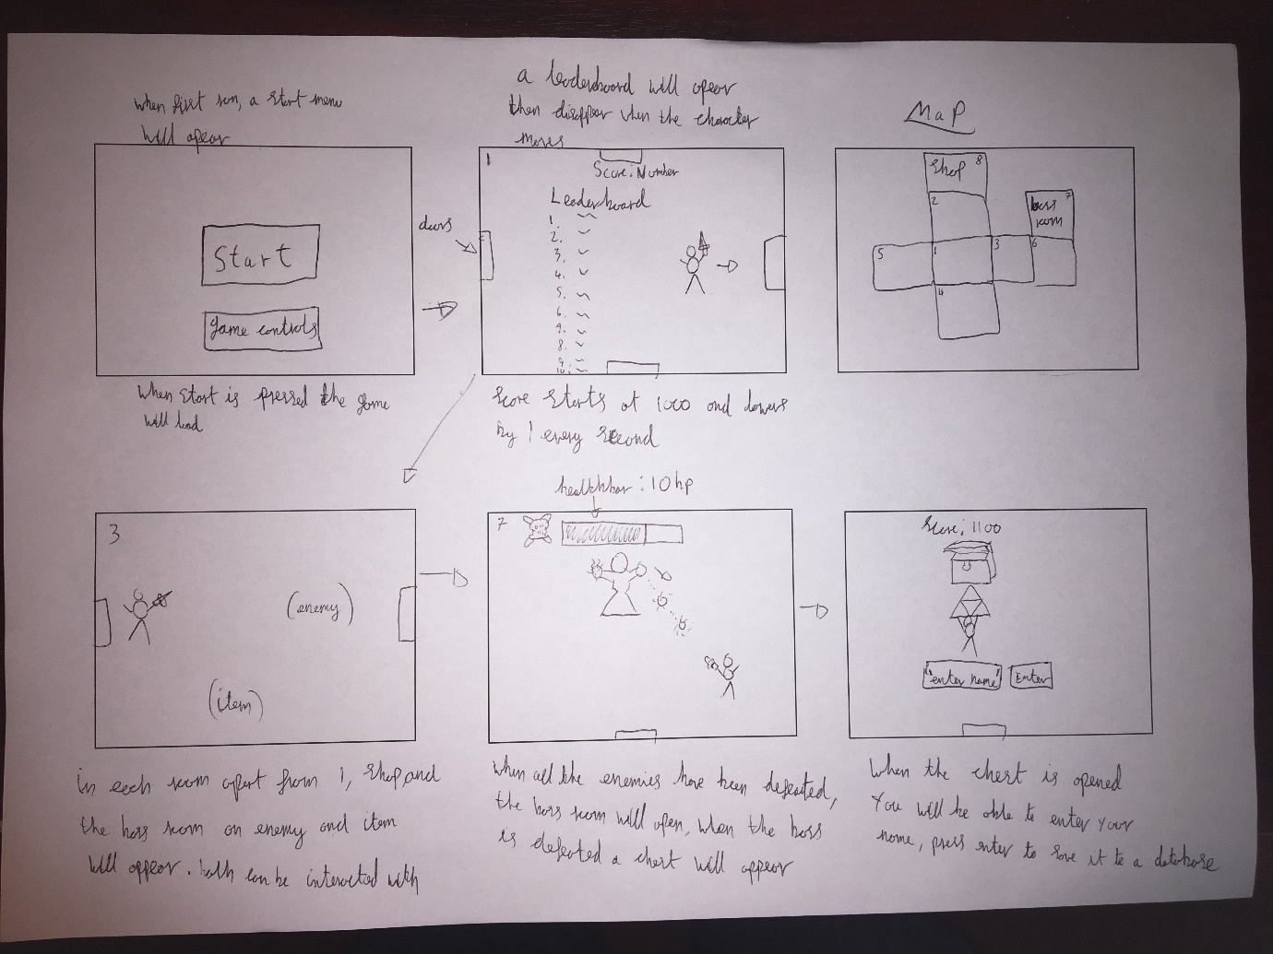

Prototype

Justification of chosen solution (linked to research)
When coding my game, I will use java in the Intellij IDE because of the coding experience I have with this language. To save the name and scores to a database I’m going to use sql with the sql management studio.

Data modelling

Design

Design introduction

